**Template: Find & document keywords to create BOARDS & BOARD descriptions**

**boardNAME (example: Elementary Education) 🡨 type your board name and variations/words of your board name into the search bar. For best results, look up all phrases and words you plan to use and choose a board name that includes popular keywords.  
(I also suggest using: www.pinterestkeywordtool.com)**

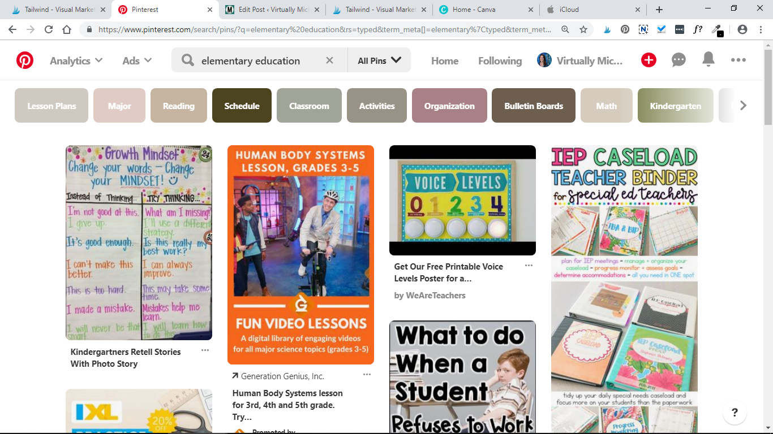

KEYWORDS: **^ Look at the colored boxes that show up under the search bar. These are the most commonly searched for variations and extensions of your word or phrase. Choose about 10-12 words to work into your description. The words you use here will give you/contributors an idea of what this boards content will be.** Example: Elementary strategies time ideas life skills respect life skills manners patience

BOARD description: **🡨 You have about 500 characters to get your idea across! Use your strongest, most searched for keywords in clear concise sentences.** As my boards grow, I may go back and edit these.

Example: Teaching goes beyond academics. The elementary age child needs to learn life skills such as respect, manners, patience, responsibility and how to use their time wisely. This board compiles strategies to help kids become the best people they can be.

**If you are making a group board you may include a link with board rules and how someone may request to join. I add: For board rules, visit:** [**https://virtuallymichelle.com/board-rules-and-request-to-join/**](https://virtuallymichelle.com/board-rules-and-request-to-join/) **OR: If you want to share pins with this group, click on the following link…**

**boardNAME 🡨 Double click boardNAME and begin typing in your own name.**

KEYWORDS:

BOARD description:

**boardNAME**

KEYWORDS:

BOARD description:

**boardNAME**

KEYWORDS:

BOARD description:

**boardNAME**

KEYWORDS:

BOARD description:

**boardNAME**

KEYWORDS:

BOARD description:

**boardNAME**

KEYWORDS:

BOARD description:

**boardNAME**

KEYWORDS:

BOARD description:

**boardNAME**

KEYWORDS:

BOARD description:

**boardNAME**

KEYWORDS:

BOARD description:

**boardNAME**

KEYWORDS:

BOARD description:

**boardNAME**

KEYWORDS:

BOARD description:

**boardNAME**

KEYWORDS:

BOARD description:

**boardNAME**

KEYWORDS:

BOARD description:

**boardNAME**

KEYWORDS:

BOARD description:

**boardNAME**

KEYWORDS:

BOARD description:

**boardNAME**

KEYWORDS:

BOARD description:

**boardNAME**

KEYWORDS:

BOARD description:

**boardNAME**

KEYWORDS:

BOARD description:

**boardNAME**

KEYWORDS:

BOARD description:

**boardNAME**

KEYWORDS:

BOARD description:

**boardNAME**

KEYWORDS:

BOARD description:

**GROUP BOARDS:**

**GROUPBOARDNAME**

KEYWORDS:

Board description:

**GROUPBOARDNAME**

KEYWORDS:

Board description:

**GROUPBOARDNAME**

KEYWORDS:

Board description:

**GROUPBOARDNAME**

KEYWORDS:

Board description:

**GROUPBOARDNAME**

KEYWORDS:

Board description:

**GROUPBOARDNAME**

KEYWORDS:

Board description:

**GROUPBOARDNAME**

KEYWORDS:

Board description:

**GROUPBOARDNAME**

KEYWORDS:

Board description:

**GROUPBOARDNAME**

KEYWORDS:

Board description:

**GROUPBOARDNAME**

KEYWORDS:

Board description:

**GROUPBOARDNAME**

KEYWORDS:

Board description:

**GROUPBOARDNAME**

KEYWORDS:

Board description:

**GROUPBOARDNAME**

KEYWORDS:

Board description:

**GROUPBOARDNAME**

KEYWORDS:

Board description: