**Template: Find & document keywords to create PINS & PIN descriptions**

**Pin TITLE 🡨 type your pin title and variations/words of your pin title into the search bar. For best results, make about 4 different pins for one blog/product/service. Look up all phrases and words you plan to use. (also use: www.pinterestkeywordtool.com)** Example: 4 Ways to Add Olive Oil into Your Diet Extra Virgin Olive Oil Seals  
 Symbols for High Quality Olive Oil 4 Ways to Effortlessly Eat More Olive Oil   
**If you are using RICH PINS, consider adding your keywords into the first paragraph of your blog, as Pinterest will pull from that 1st paragraph to use as the PIN description. Use several keywords in a few different blog titles – document these keywords and alternative blog titles in your blog document and take note of which ones were most popular. You have to add keywords/tags into your post and description anyway, so doing 5 minutes of great research will end up saving you time and it will help your post be more popular!**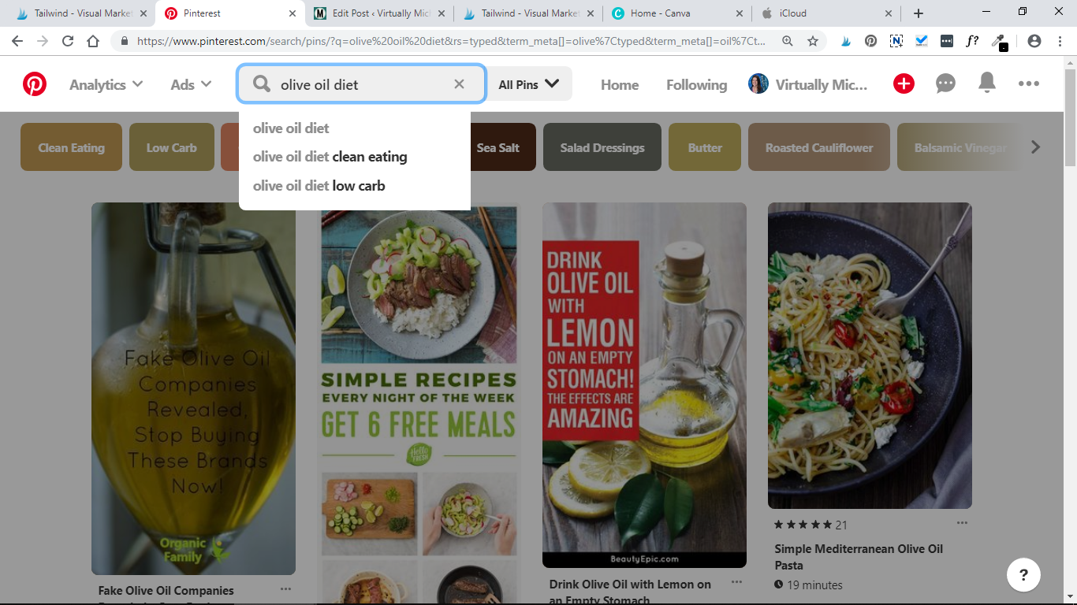

KEYWORDS:   
**^ Look at the colored boxes that show up under the search bar. These are the most commonly searched for variations and extensions of your word or phrase. Choose about 10-12 words to work into your pin description. Take note of the other suggestions in the drop down menu, and popular pin titles that come up as well!**   
Example: Olive oil, dips, recipes, olive oil dishes, salad dressing, best olive oil to buy, benefits, heart, anti-inflammatory, anti-oxidant, vitamins, digestion, cholesterol, omega-3, clean eating, low carb, gluten-free, butter, roasted cauliflower, balsamic vinegar, garlic, meals, bread, sauce, pasta, packaging, Mediterranean

PIN description: **🡨 You have about 500 characters to get your idea across. Use your strongest, most searched for keywords in clear concise sentences. If you want your pin to be found, make sure you are using the words that people are actually searching for. You may find yourself altering your content to make it geared toward what is being frequently searched for.**   
Example: “**Mediterranean** is one of the most heart healthy diets. It includes a lot of olive oil, garlic and even **balsamic vinega**r. **Extra virgin olive oil** can be used in place of **butter**, **sauce** & **salad** **dressing** when you eat **bread**, **pasta**, or alternatively use **cauliflower** in place of grains. This oil **benefits** your body with its anti-inflammatory and anti-oxidant properties (and more!) – It’s a great addition to those who aspire to **clean eating**.

Suggested daily consumption recommendations range from 2-12 TBSP a day. I like to add it into recipes and **dips** to eat as much as possible. For each meal, I ask myself, how can I add olive oil to this? (See link at end on how to buy the BEST quality oil. TIP: I’ve included images of the seals which signify that an oil is pure, undiluted and processed correctly.) It may be difficult to eat more olive oil, but here are some reasons to try.”   
**(When Pinterest pulls this text from my blog website, it won’t catch all the characters, but that’s okay – hopefully it’s enough to grab the reader’s attention so they’ll click through. Be careful not to give away all the ‘answers’ in this opening paragraph!**

**pinTITLE 🡨 Double click pinTITLE and begin typing in your own title.**

KEYWORDS:

PINdescription:

**pinTITLE**

KEYWORDS:

PINdescription:

**pinTITLE**

KEYWORDS:

PINdescription:

**pinTITLE**

KEYWORDS:

PINdescription:

**pinTITLE**

KEYWORDS:

PINdescription:

**pinTITLE**

KEYWORDS:

PINdescription:

**pinTITLE**

KEYWORDS:

PINdescription:

**pinTITLE**

KEYWORDS:

PINdescription:

**pinTITLE**

KEYWORDS:

PINdescription:

**pinTITLE**

KEYWORDS:

PINdescription:

**pinTITLE**

KEYWORDS:

PINdescription:

**pinTITLE**

KEYWORDS:

PINdescription:

**pinTITLE**

KEYWORDS:

PINdescription:

**pinTITLE**

KEYWORDS:

PINdescription:

**pinTITLE**

KEYWORDS:

PINdescription:

**pinTITLE**

KEYWORDS:

PINdescription:

**pinTITLE**

KEYWORDS:

PINdescription:

**pinTITLE**

KEYWORDS:

PINdescription:

**pinTITLE**

KEYWORDS:

PINdescription:

**pinTITLE**

KEYWORDS:

PINdescription: